**CLOUD AWS HANDS ON**

**Connecting RDS to MySQL**

**NAME: RAJANYA KAMILYA**

**EMPLOYEE ID: 2320828**

**COHORT CODE: CSDAIA24DB002**

**Amazon Relational Database Service (RDS)**

Amazon RDS (Relational Database Service) is a cloud-based database service provided by Amazon Web Services (AWS). It falls under the category of Platform as a Service (PaaS). It is easier to set up, operate, and scale a relational database in the cloud. It supports popular database engines such as MySQL, PostgreSQL, Oracle, SQL Server, and MariaDB, handling routine database tasks like provisioning, patching, backup, recovery, and scaling, allowing users to focus on application development rather than managing database infrastructure.

Some key features and benefits of AWS RDS include:

**1.** **Managed Service:** AWS handles routine database tasks such as provisioning, patching, backup, recovery, and scaling, reducing administrative overhead for users.

**2.** **Multi-Engine Support:** Amazon RDS supports various relational database engines including MySQL, PostgreSQL, Oracle, SQL Server, and MariaDB, allowing users to choose the one that best fits their application requirements.

**3. Automated Backups and Point-in-Time Recovery:** RDS automatically performs backups of your database and enables point-in-time recovery, providing data protection and easy restoration in case of accidental data loss or corruption.

**4. High Availability and Fault Tolerance:** RDS offers features such as Multi-AZ (Availability Zone) deployments and Read Replicas to enhance availability, fault tolerance, and performance of database instances.

**5. Scalability:** With Amazon RDS, users can easily scale their database instances vertically (by adjusting instance size) or horizontally (by adding Read Replicas) to accommodate changing workloads and performance requirements.

**6. Security:** RDS provides robust security features including network isolation, encryption at rest and in transit, authentication mechanisms, and integration with AWS Identity and Access Management (IAM) for access control.

**7. Monitoring and Metrics:** AWS CloudWatch integration allows users to monitor database performance metrics and set up alarms for automated notifications in case of performance issues or resource utilization breaches.

Overall, Amazon RDS simplifies the process of deploying and managing relational databases in the cloud, enabling developers to focus more on building applications and less on managing database infrastructure.

**Steps for static website hosting using S3 bucket**

1. Creation of VPC.

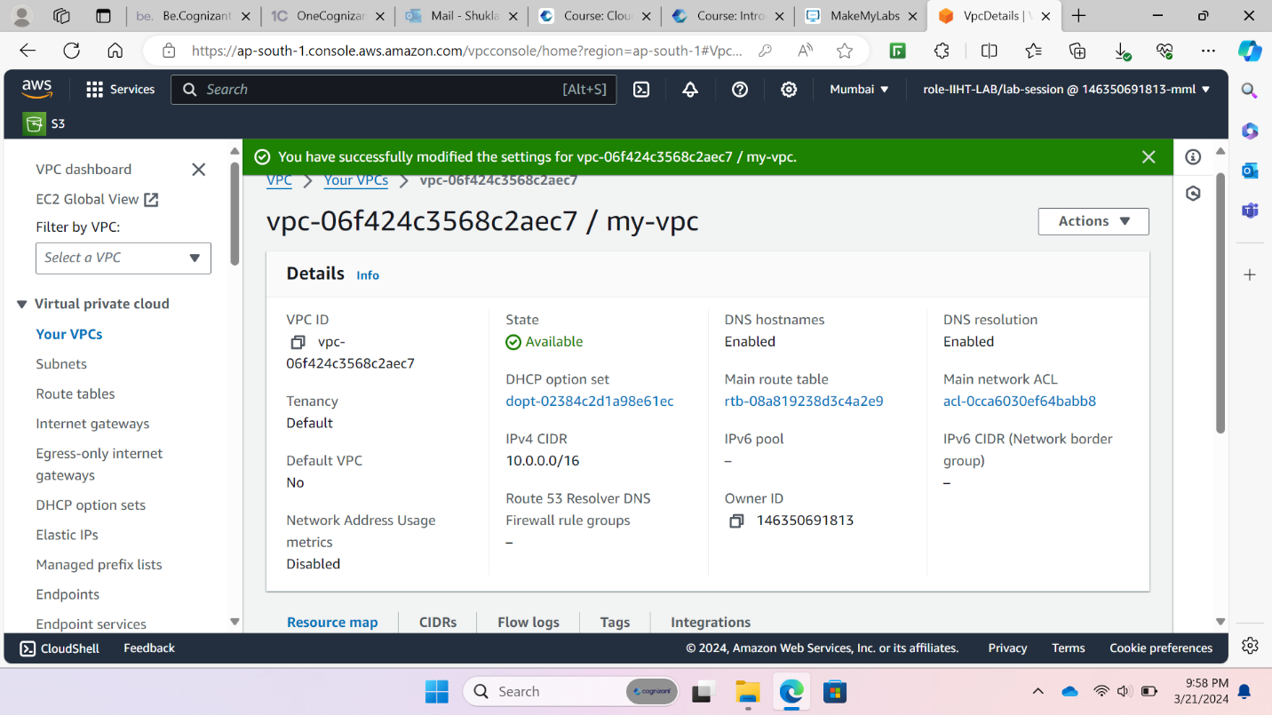

1. Creation of subnets

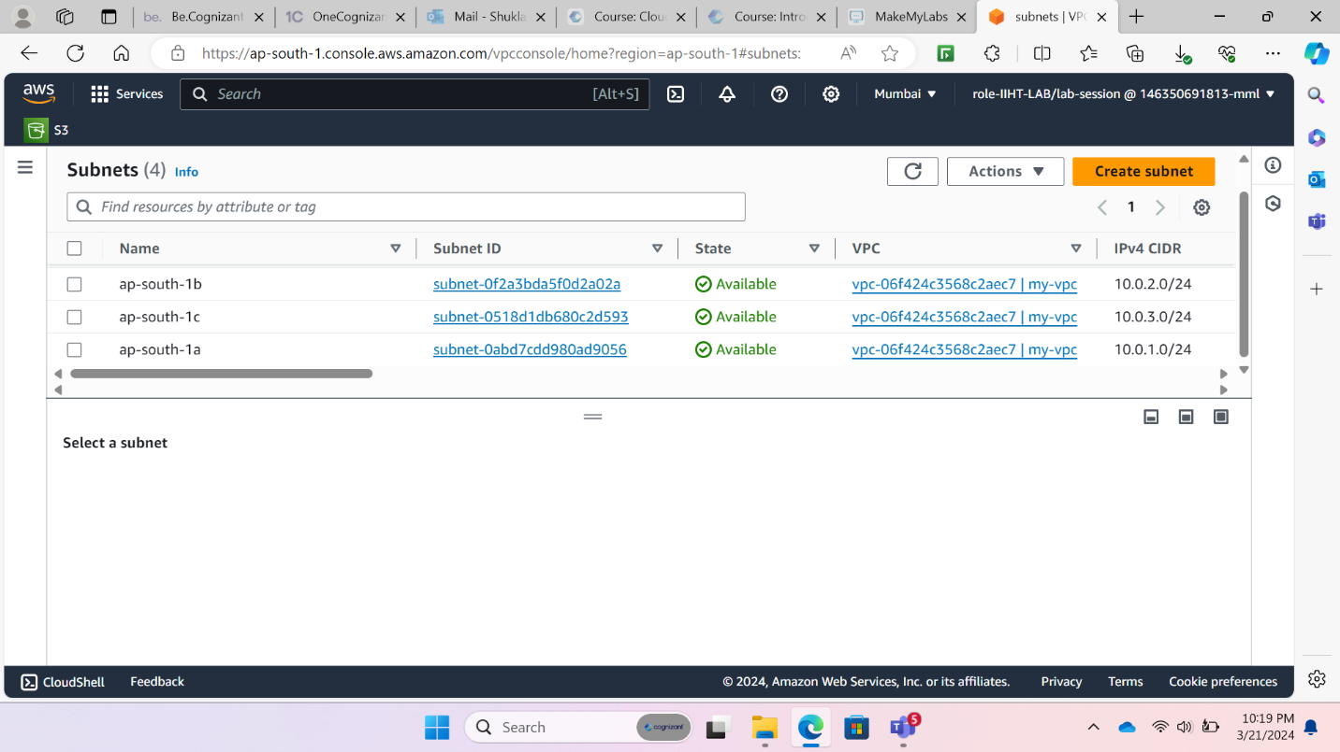

1. Creating Internet gateway for the VPC and attaching it to the created VPC

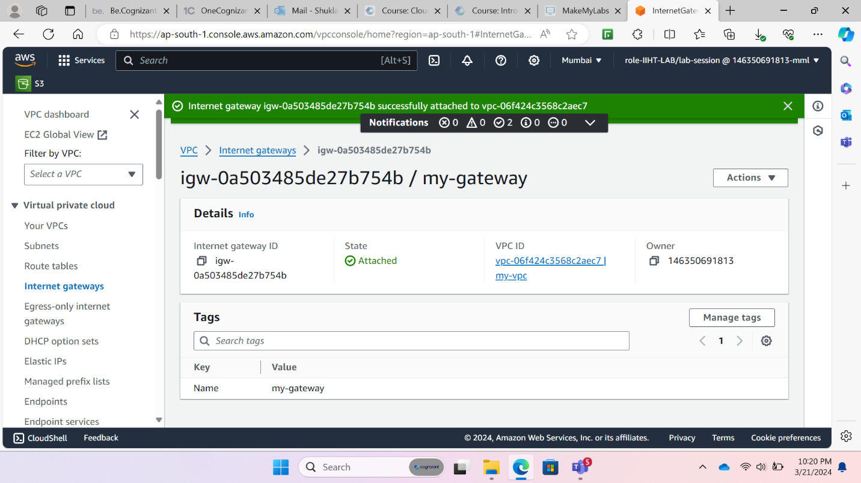

1. Creating route tables and adding a route to your created internet gateway

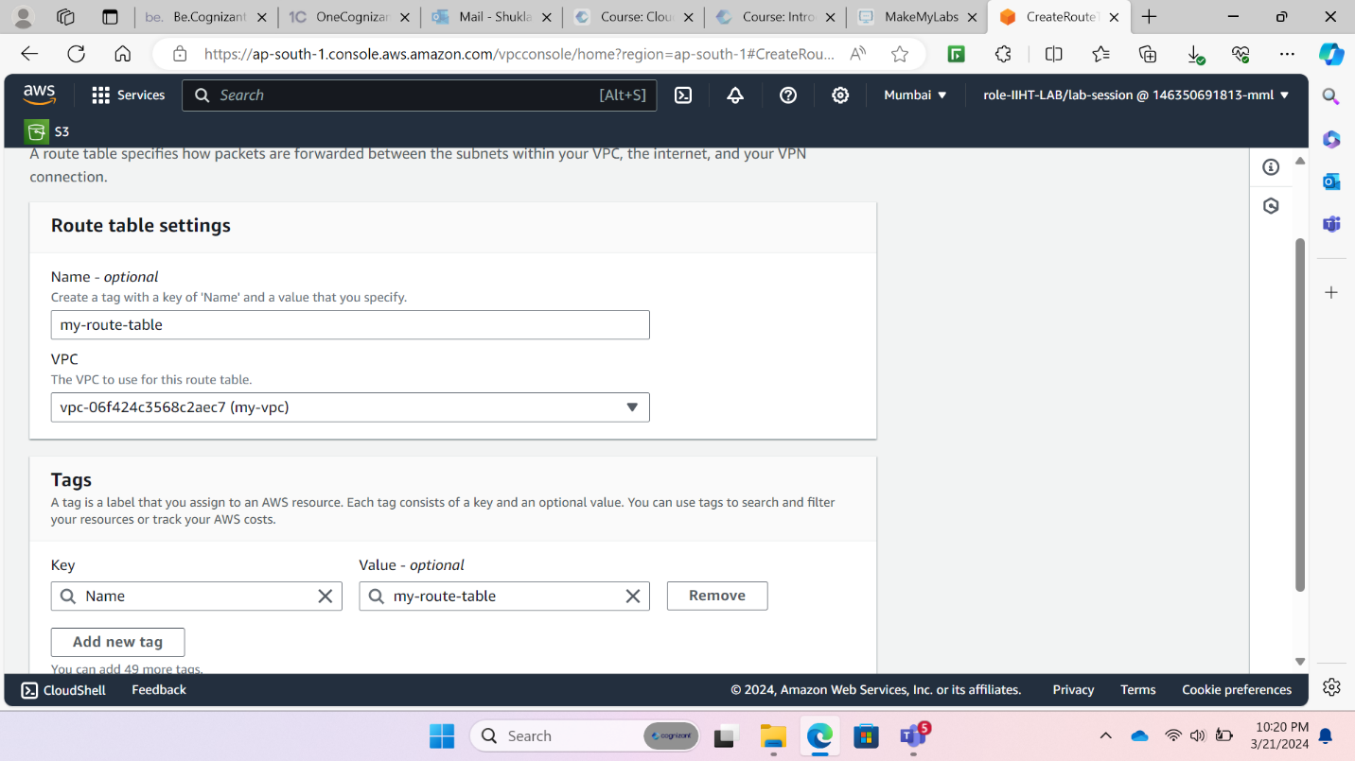

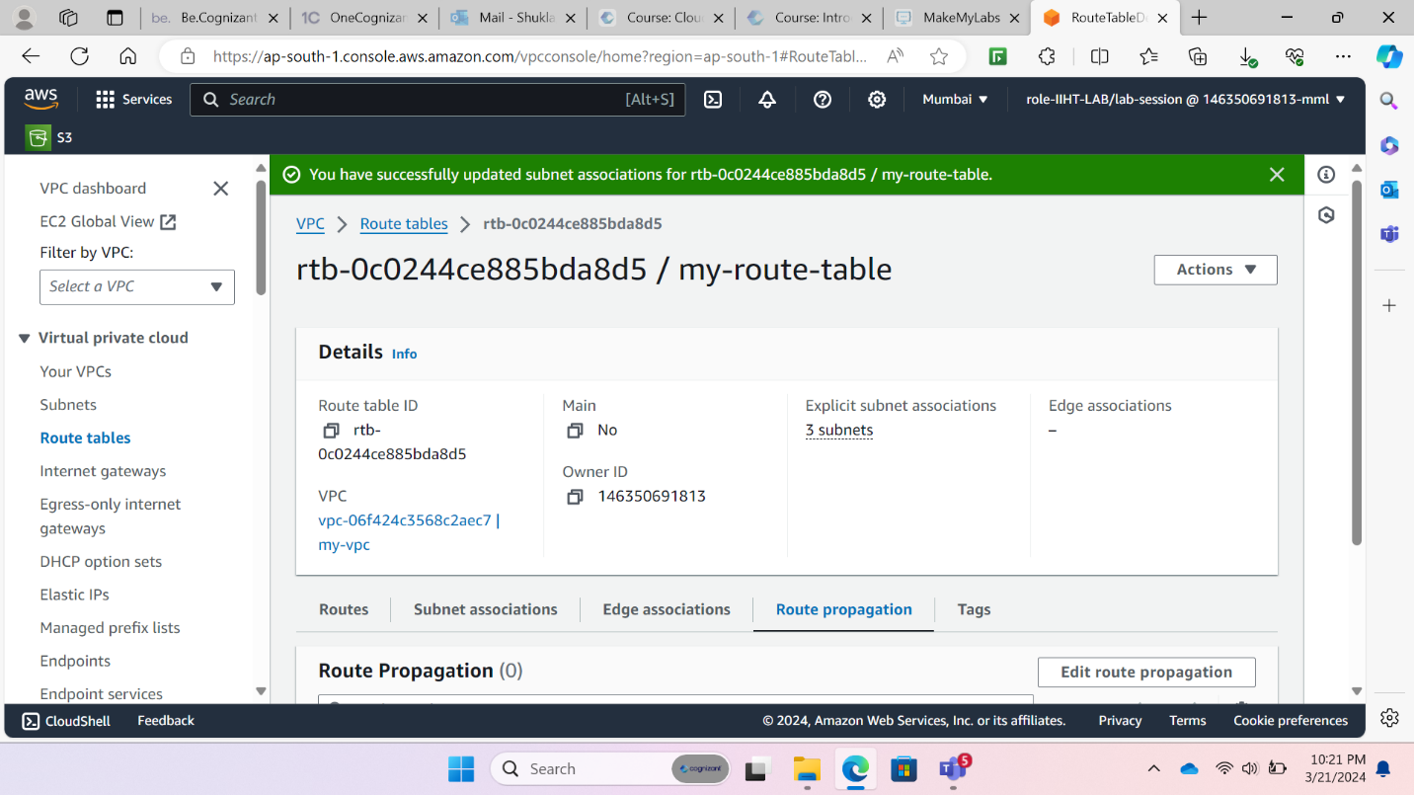

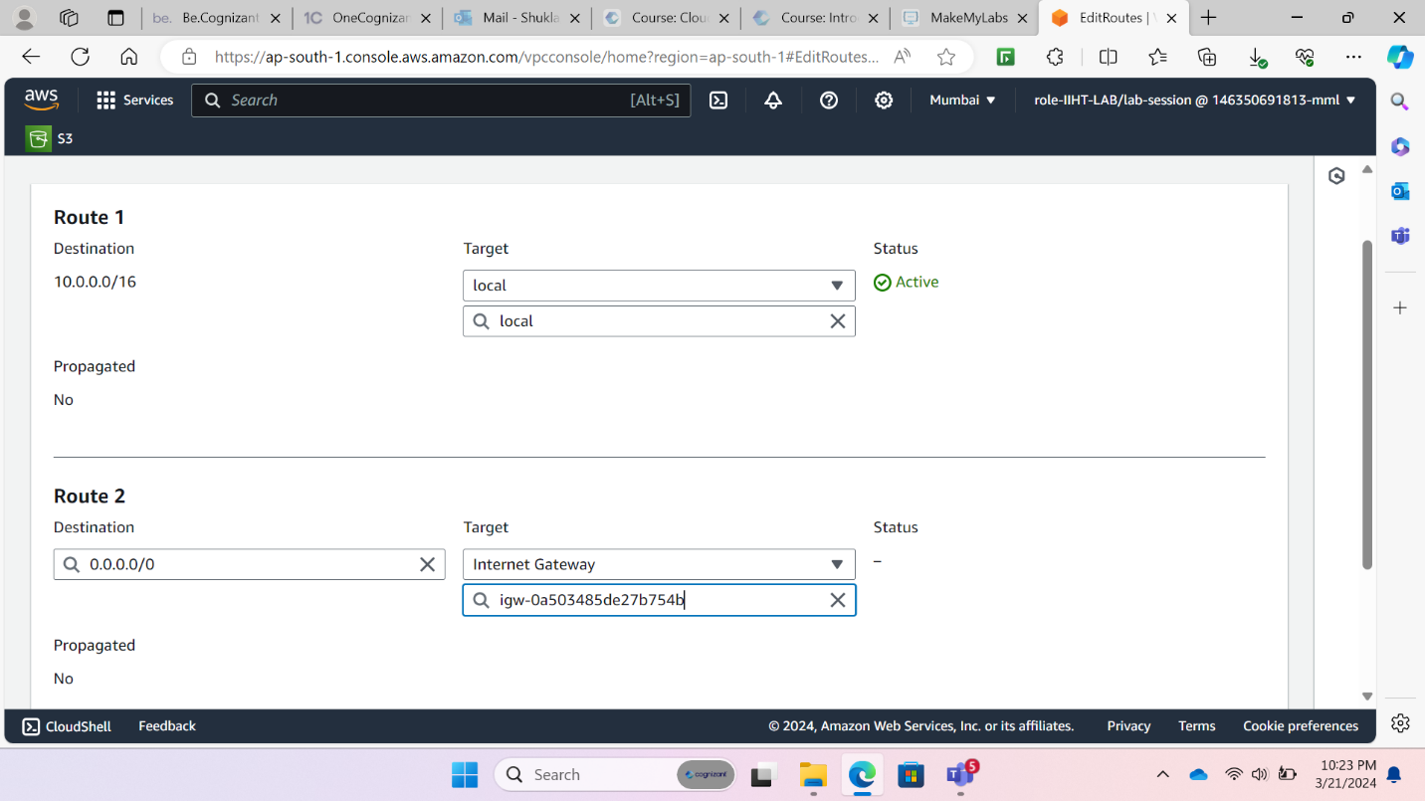

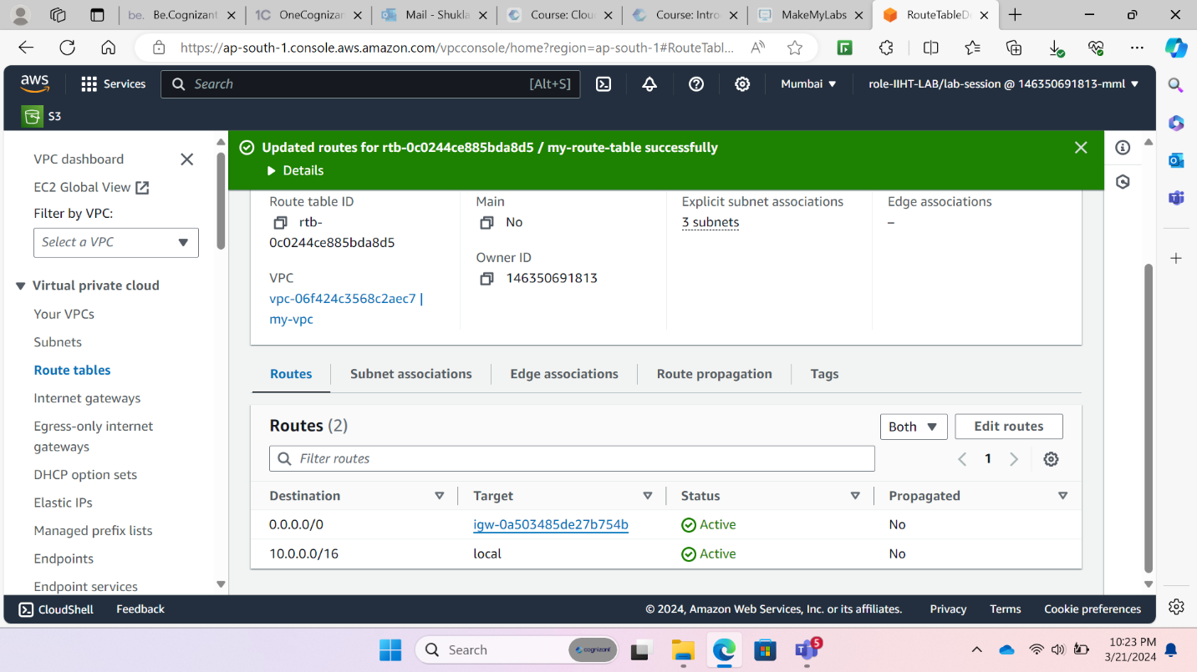

1. Creating security group for allowing MySQL traffic

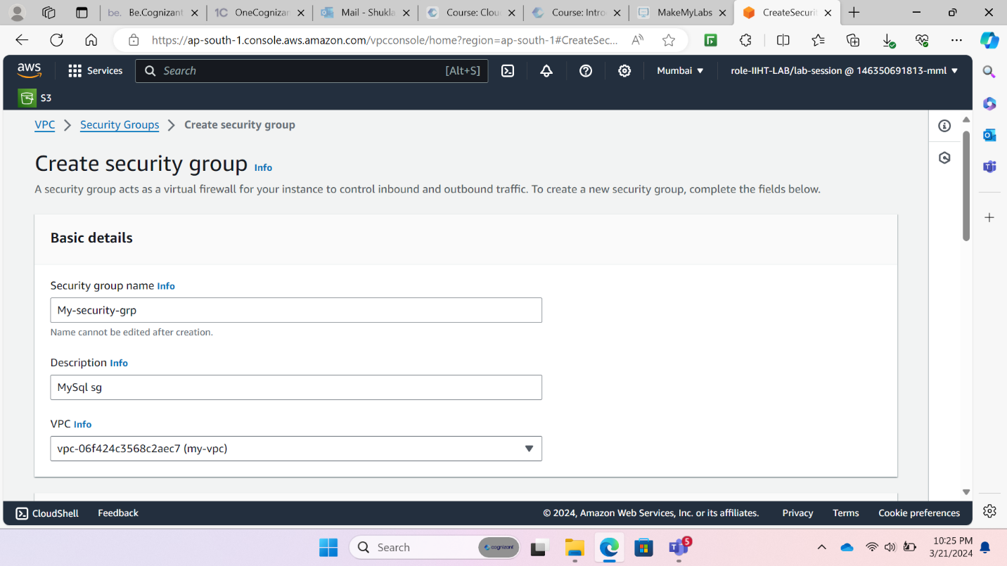

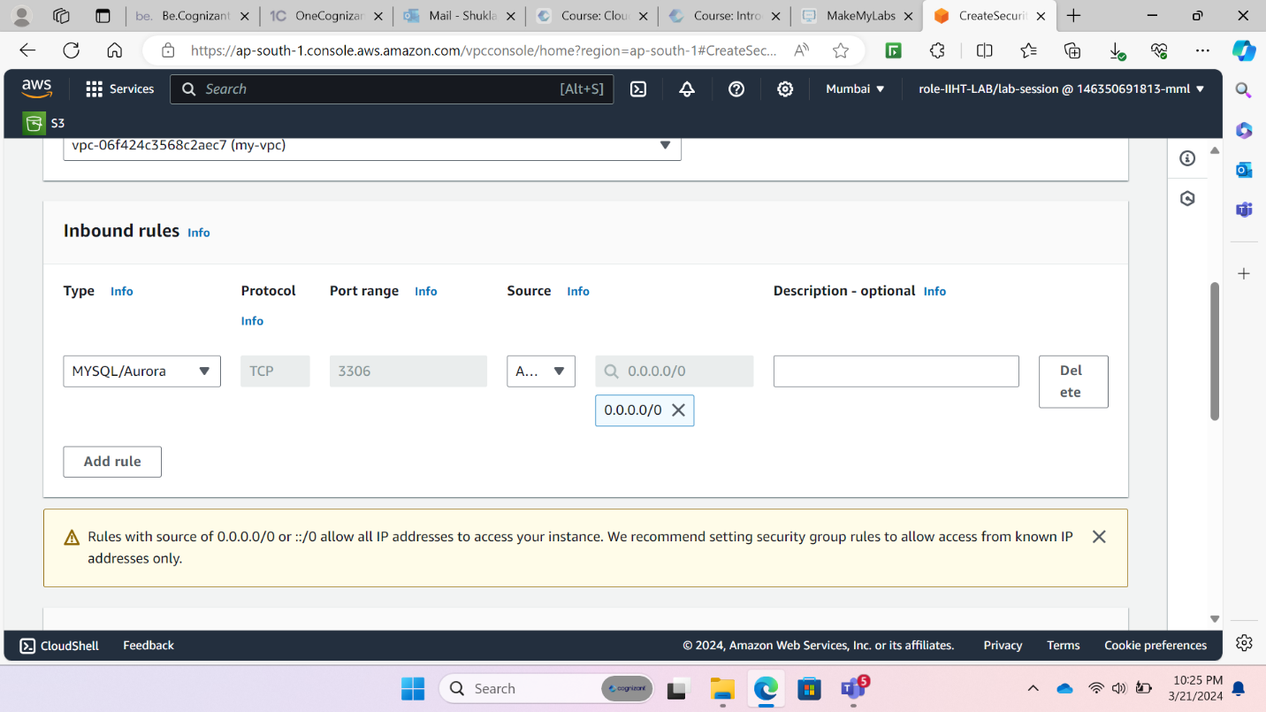

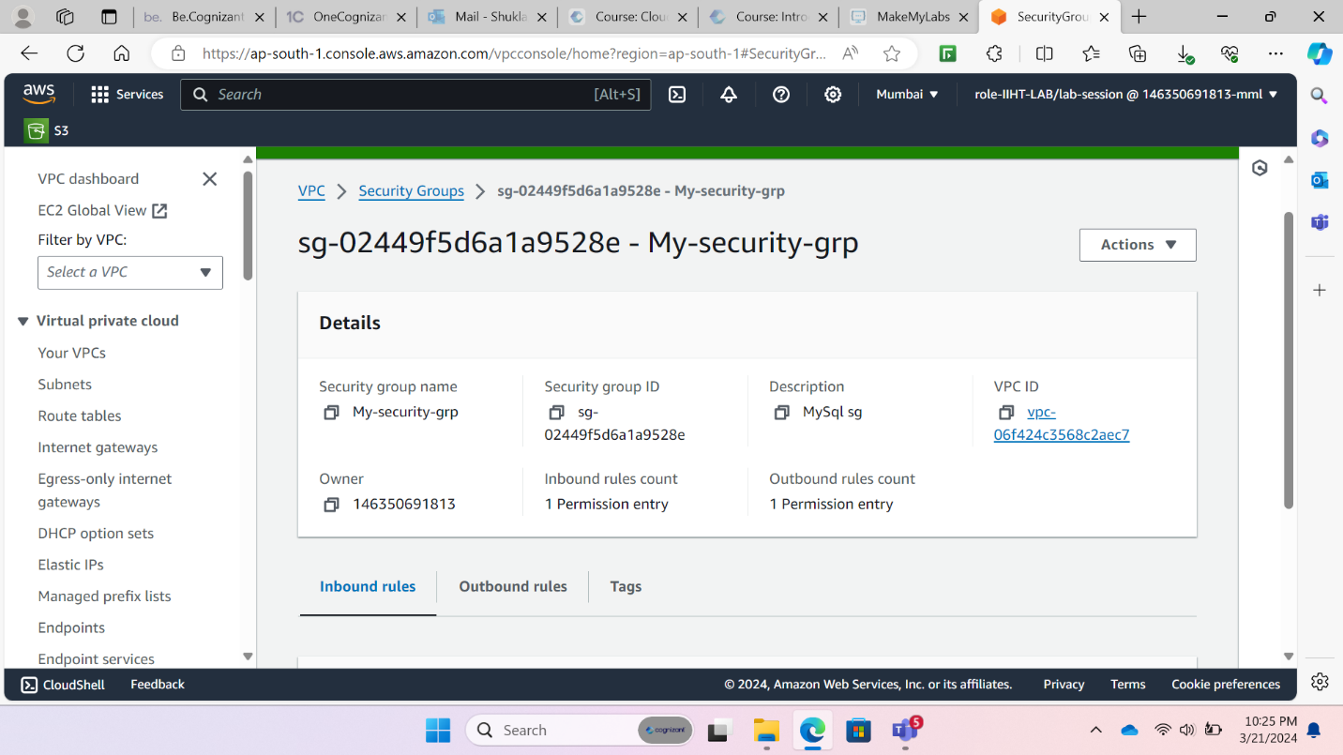

1. Creating a RDS database

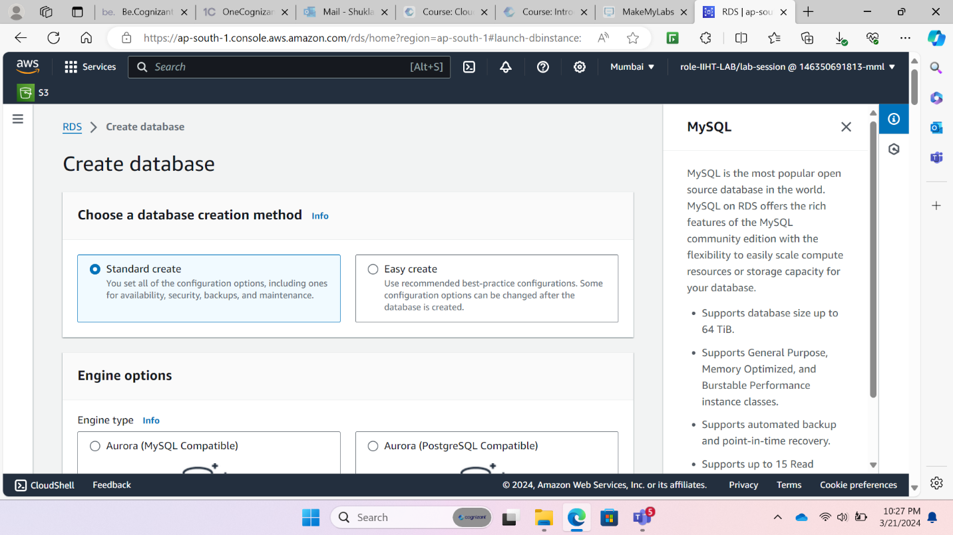

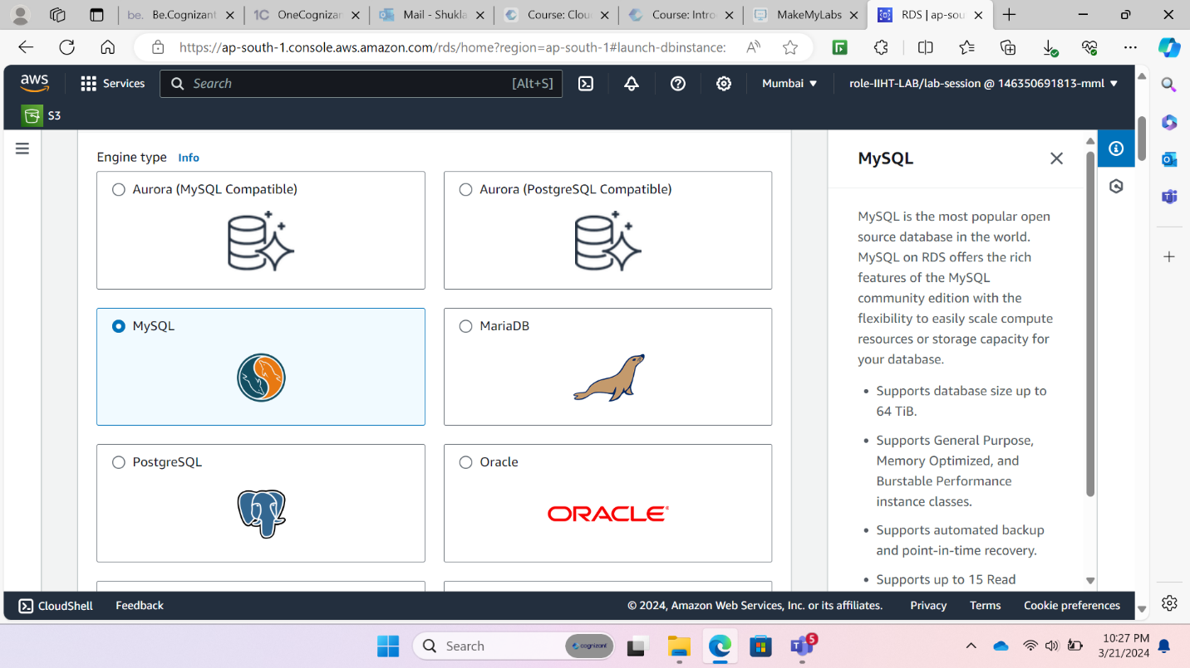

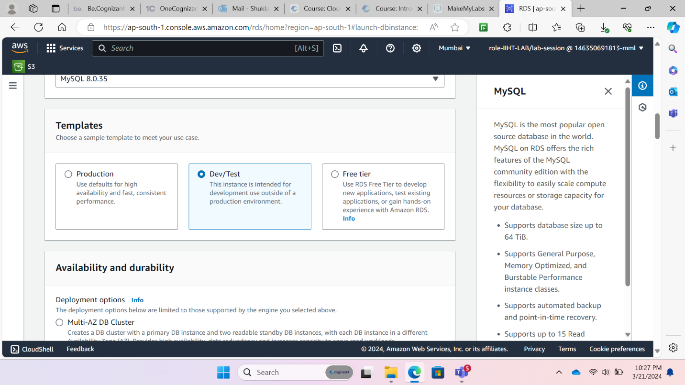

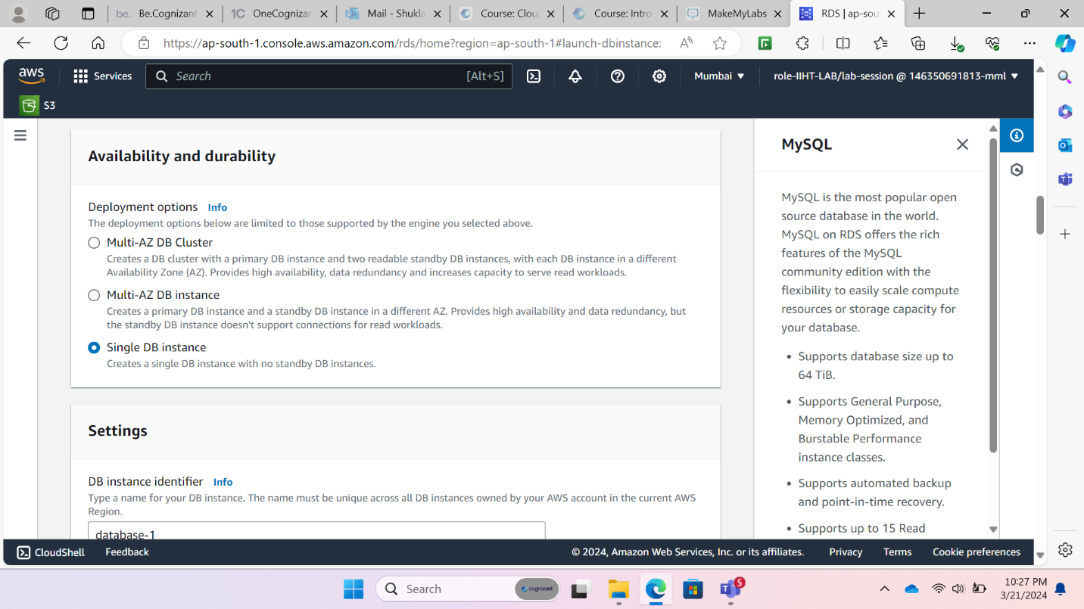

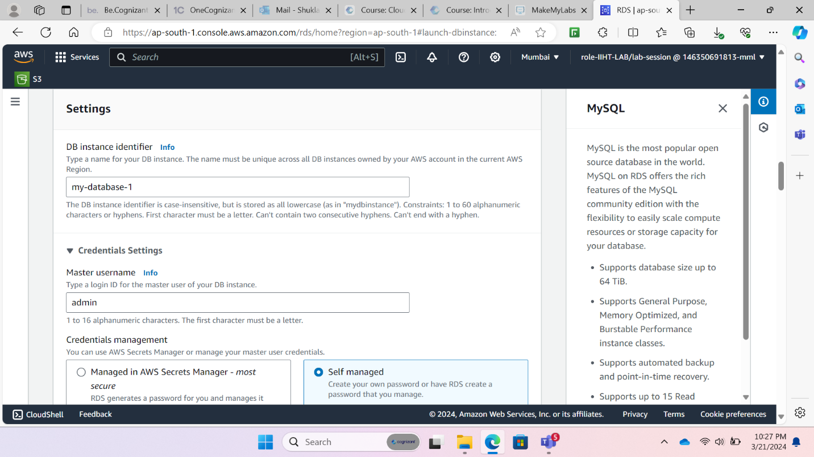

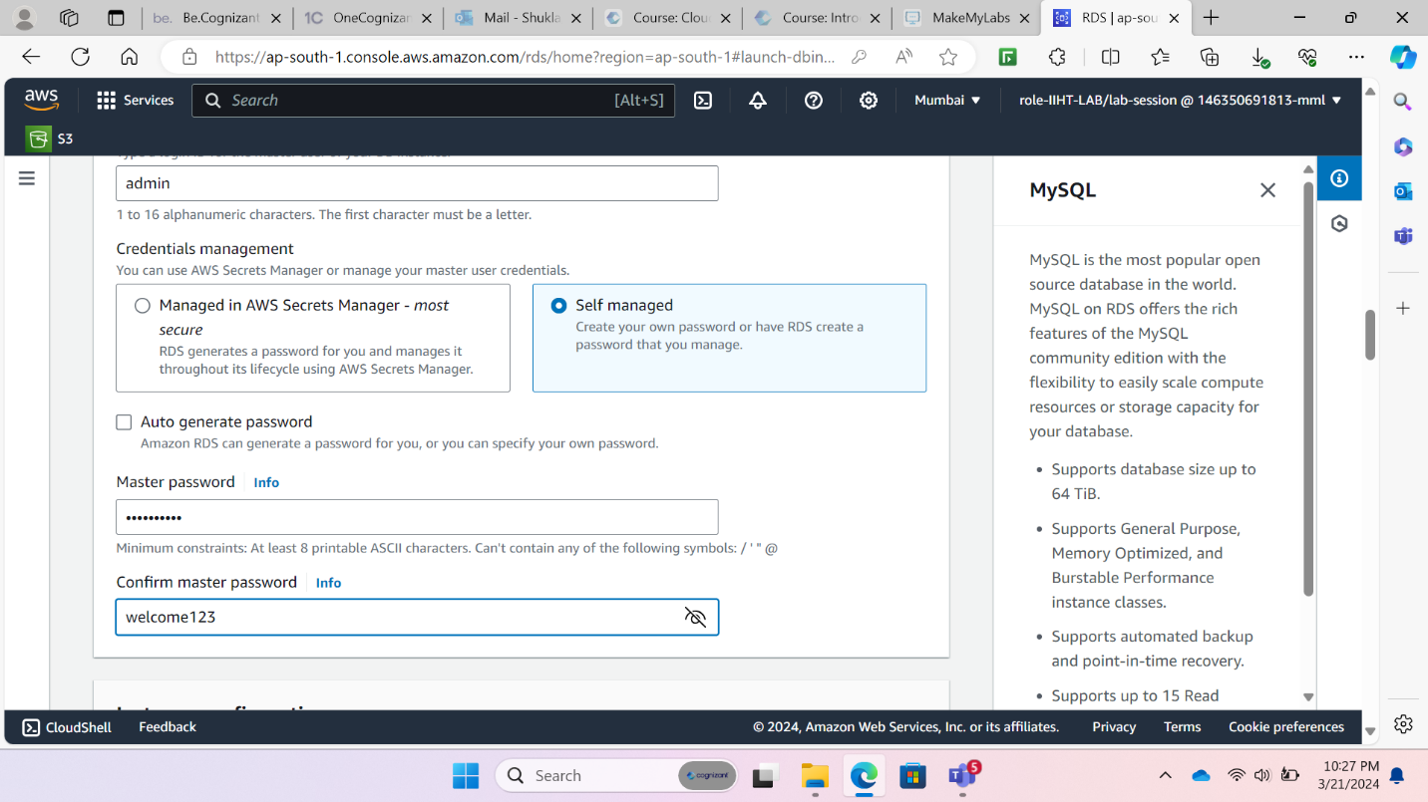

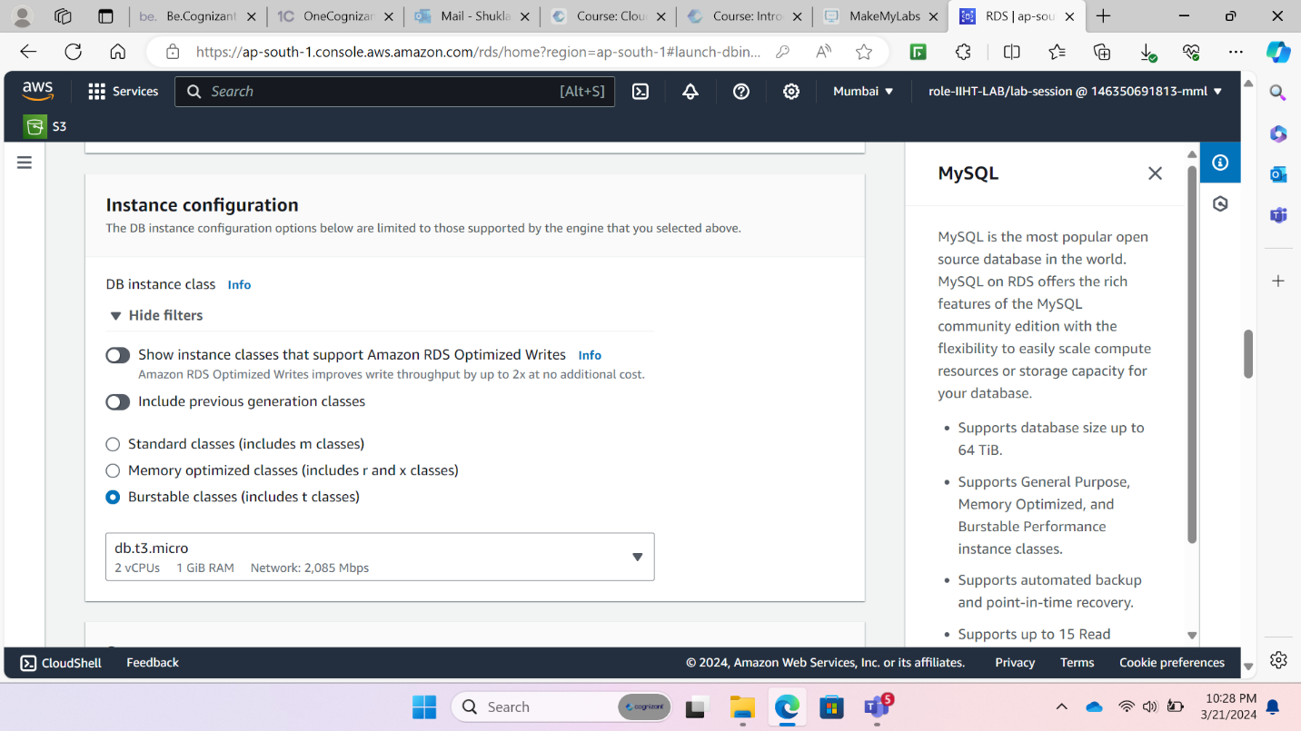

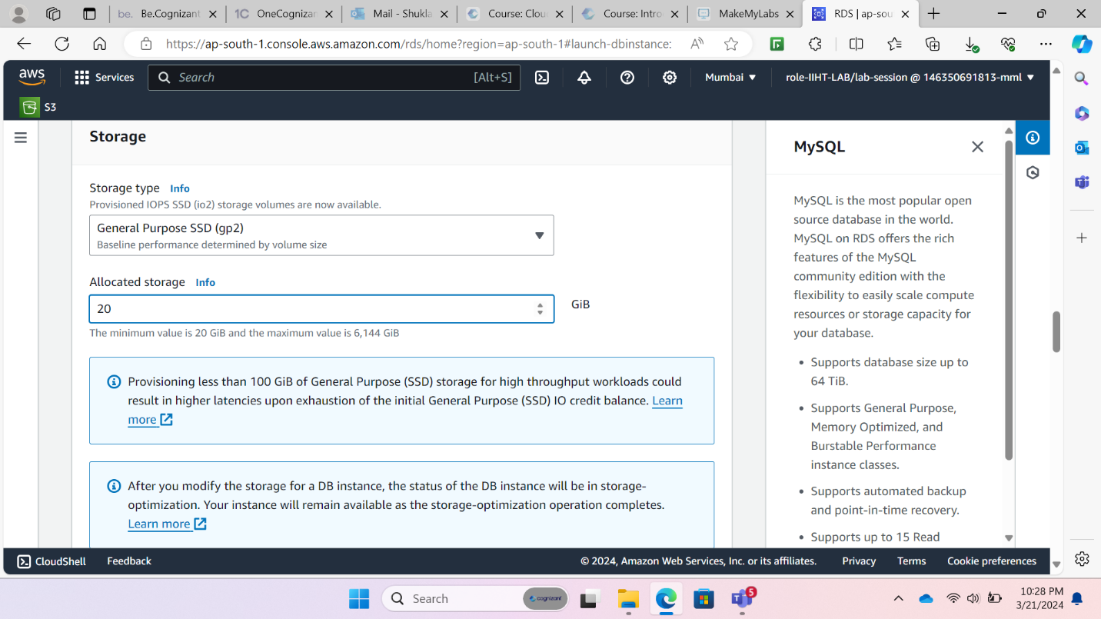

1. Attaching RDS database to the created VPC and adding the security group to allow MySQL traffic

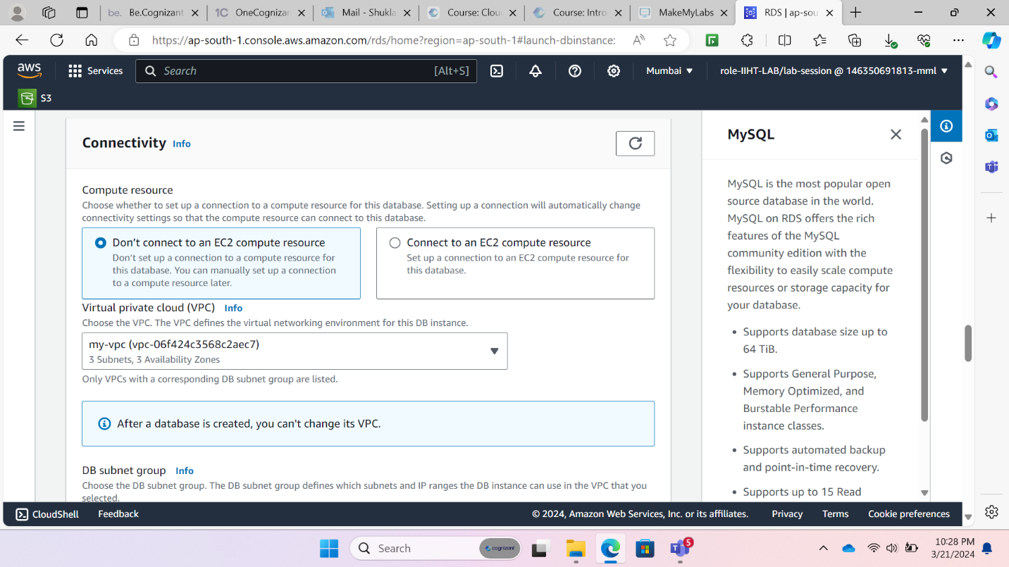

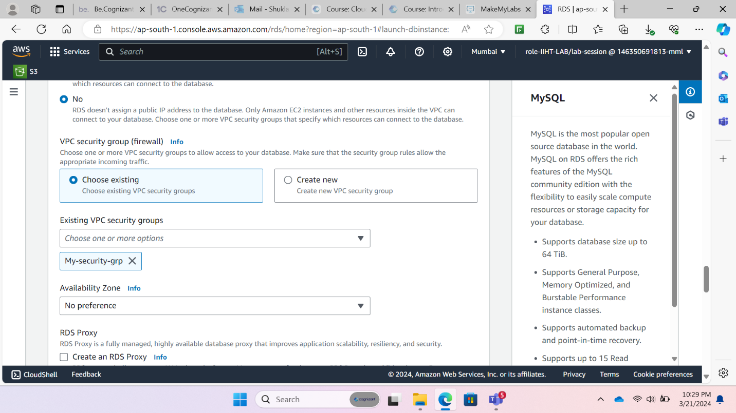

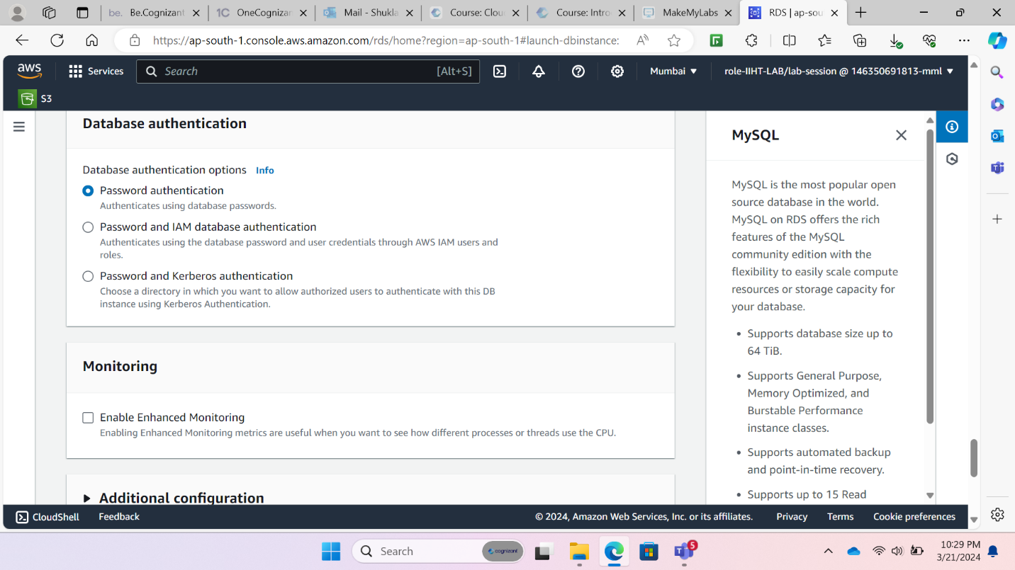

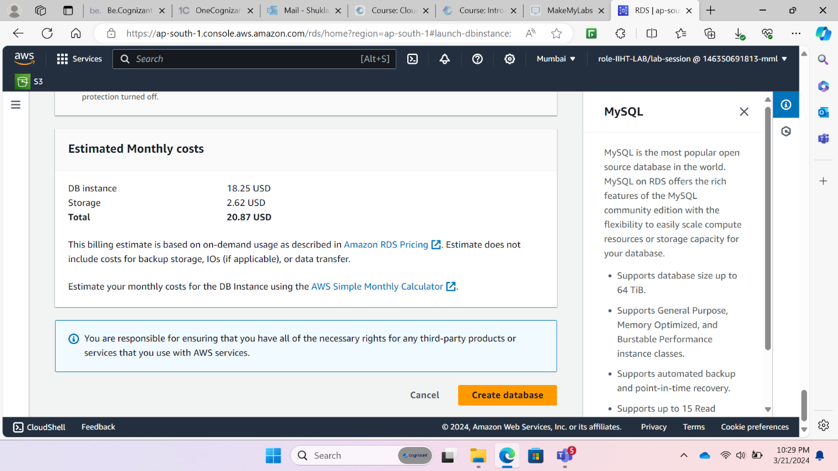

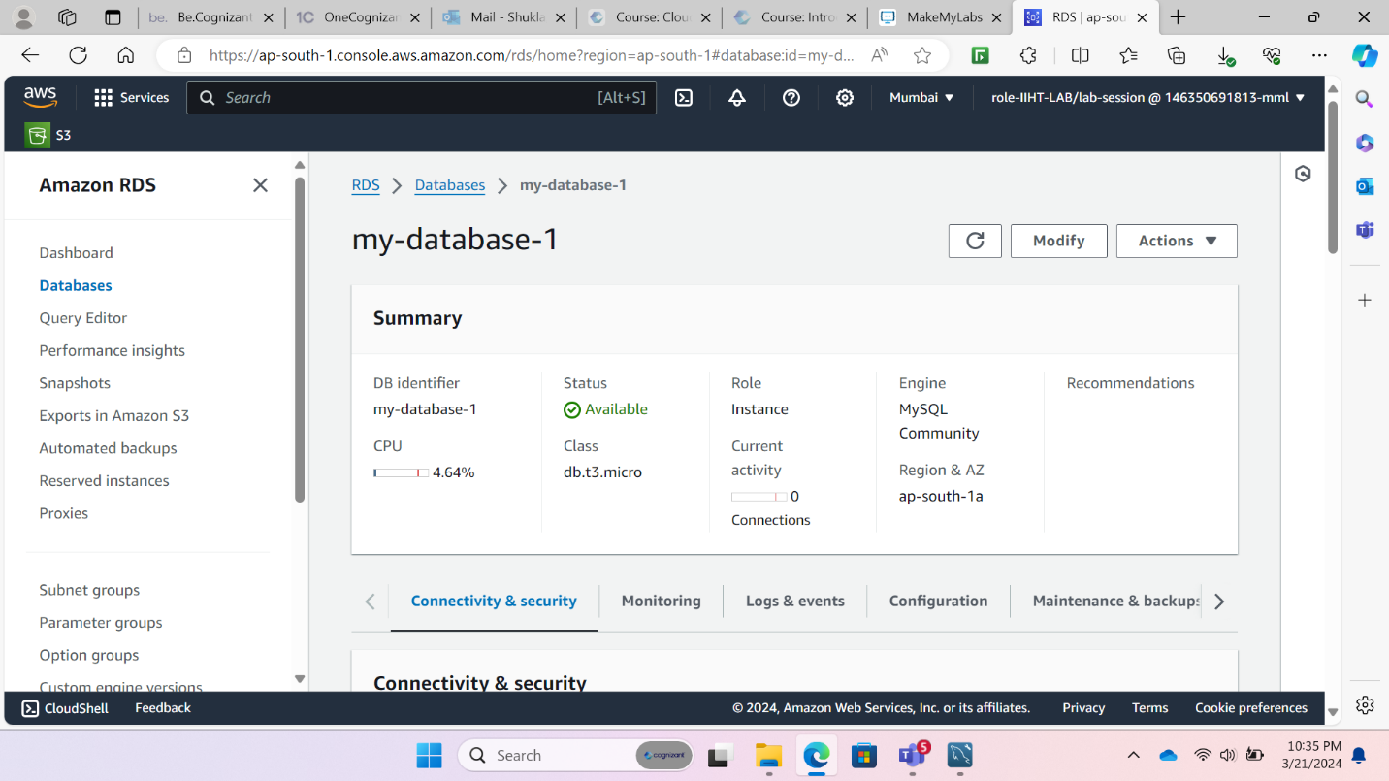

1. Note the endpoint of your created RDS database

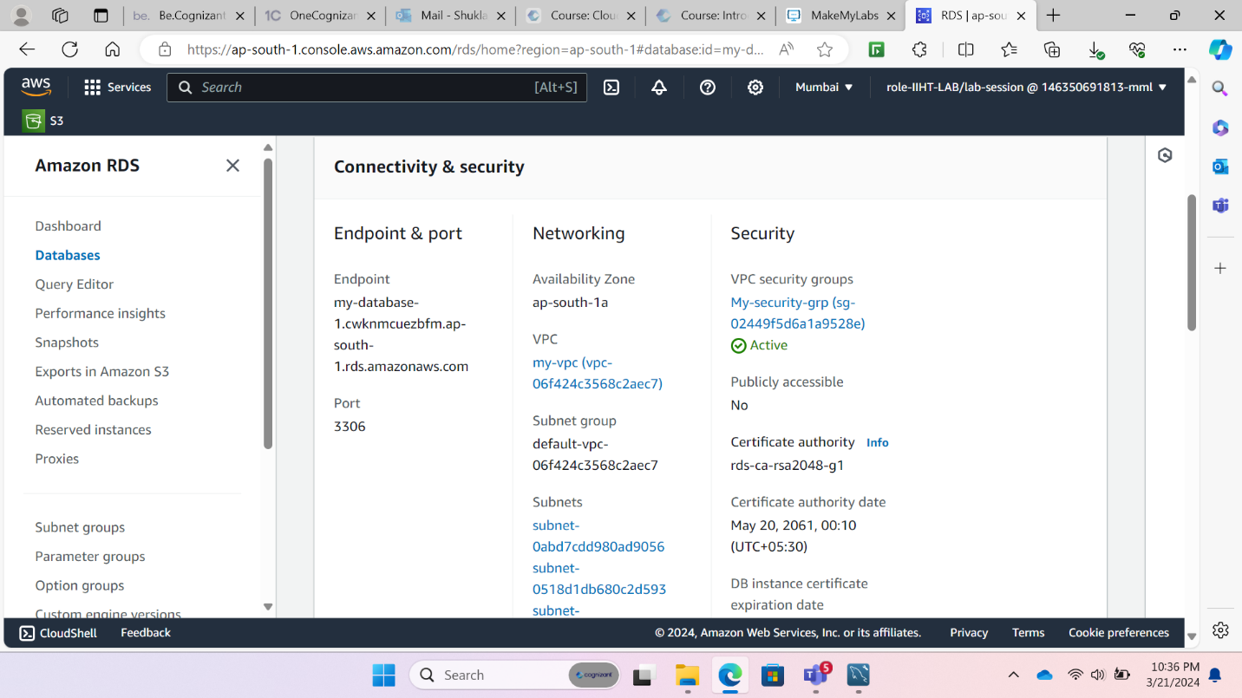

1. Make the created RDS database publicly accessible

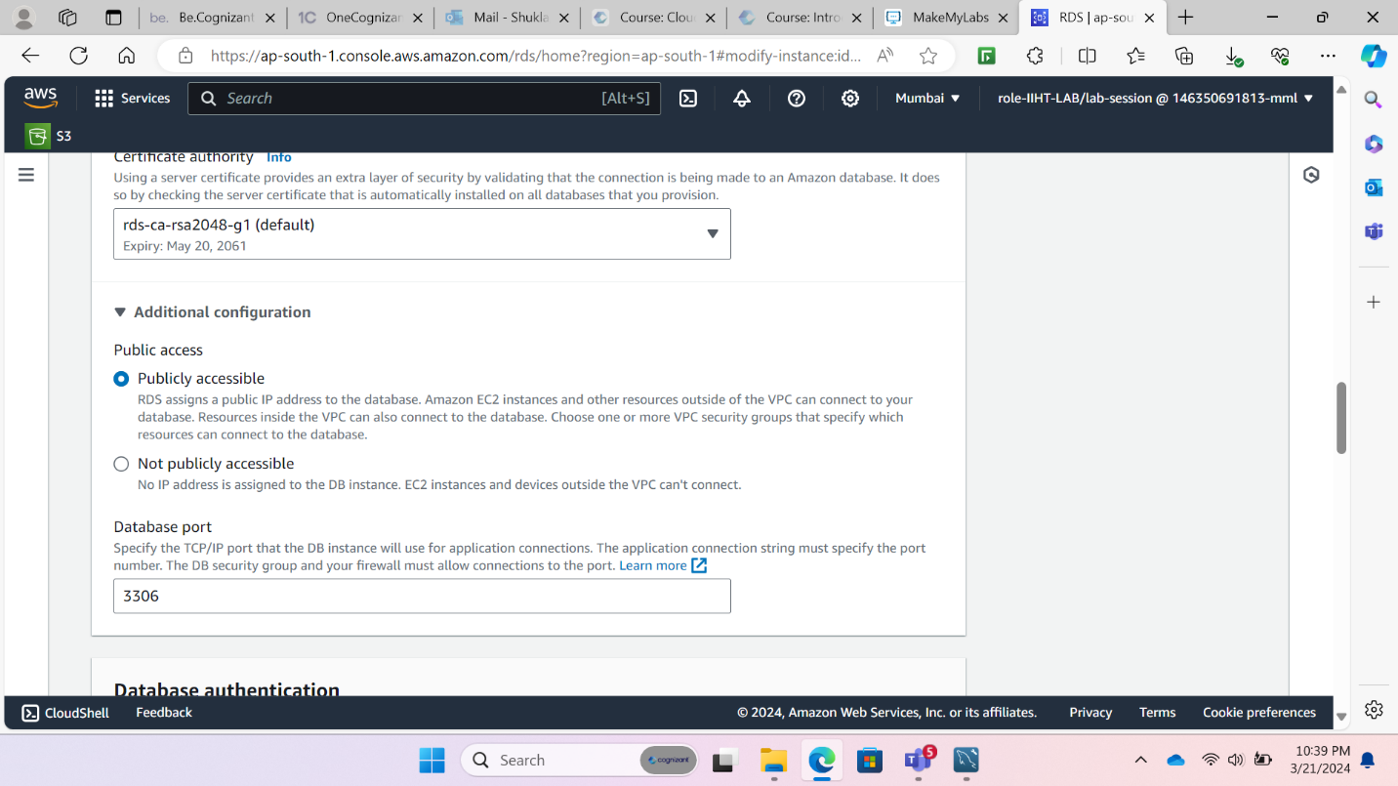

1. Open MySQL workbench and create a new connection

MySQL workbench->Set-up new connection->Paste the endpoint of the created RDS database in hostname->Enter username and password->Test Connection

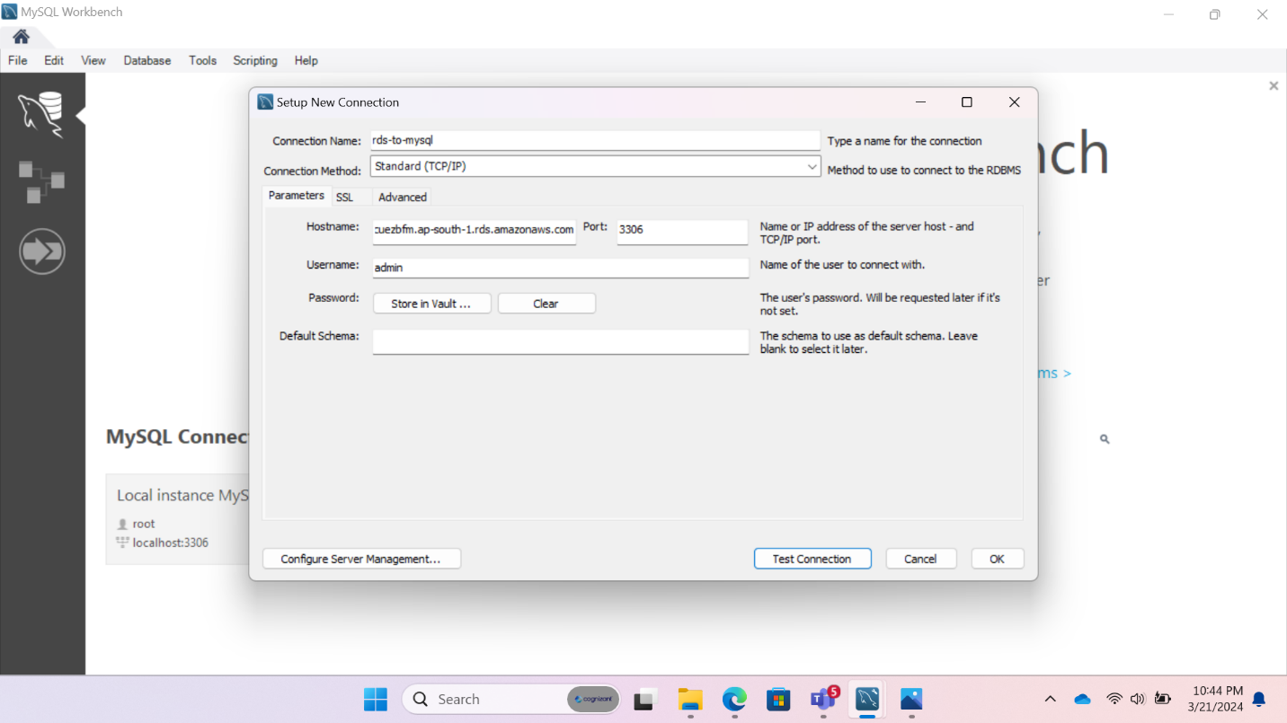

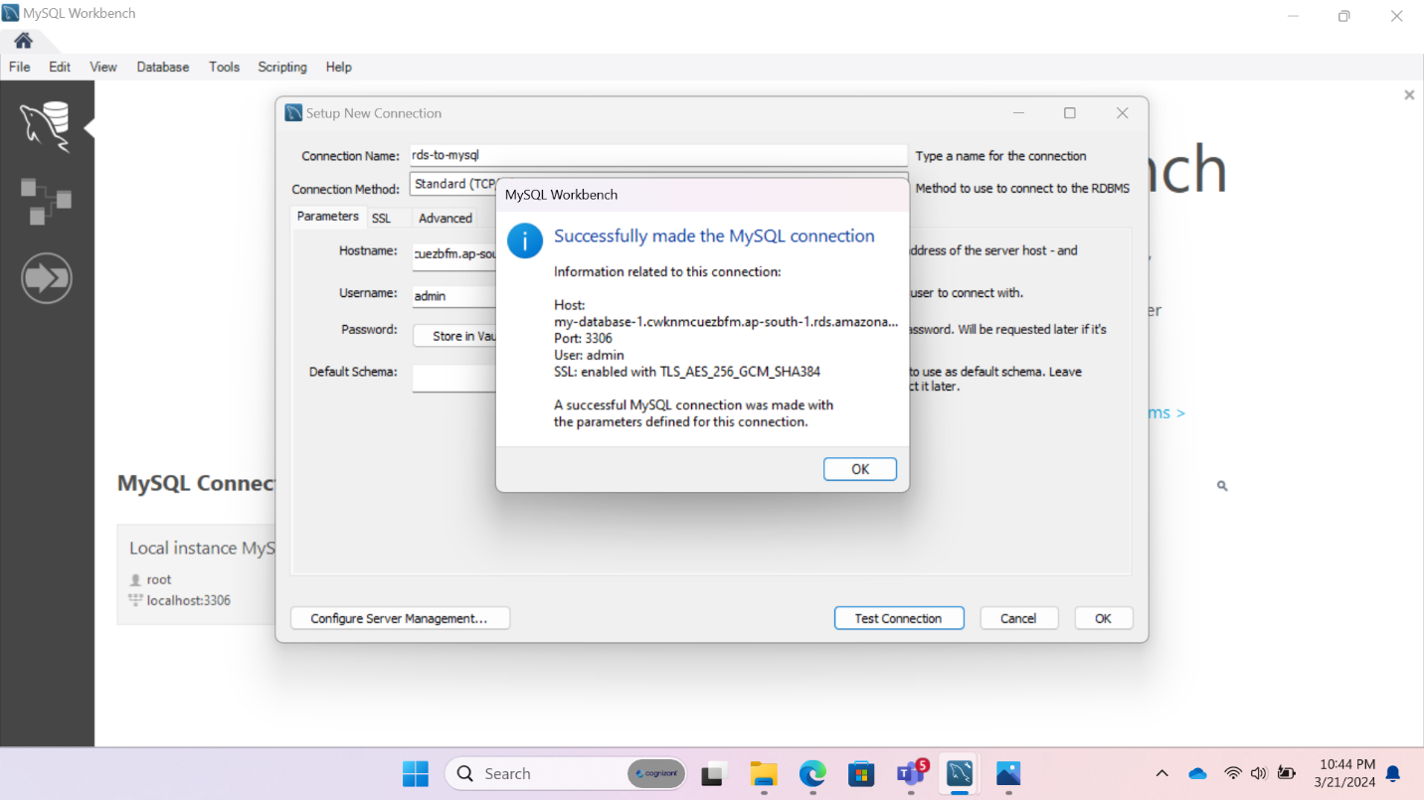

The Amazon RDS has successfully been connected to the MySQL workbench.